29.62: Wire 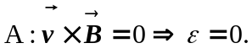
Wire C:
Wire D:

